# Physics 30 Lessons 1 to 18 Review

# Conceptual understanding

1. How could a neutral insulated metal conductor be given a negative charge using:

A. a negatively charged rod?

B. a positively charged rod?

Use diagrams to support your answer.

2. Why does rubbing a conductor not produce a static charge whereas rubbing an insulator can produce a static charge?

3. If a negatively charged rod is brought near the knob of a positively charged electroscope, what will happen to the separation between the leaves of the electroscope? Explain.

4. A positively charged rod is brought near an electroscope that is already charged. If the leaves spread further apart, what kind of charge does the electroscope have? Explain.

5. Given a solid metal sphere and a hollow metal sphere, each with the same radius, which will hold the greater charge? Justify your answer.

**Problem solving**

1. A fullback with a mass of 95 kg running at 8.2 m/s collides with a 128 kg defensive tackle moving in the opposite direction. They end up with zero speed. Calculate how fast the tackle must have been moving. (–6.1 m/s)
2. A 2575 kg van runs into the back of a 825 kg compact car that was at rest. They move off together at 8.5 m/s. What was the initial speed of the van? (11 m/s)
3. A hockey puck mass 0.115 kg moving at 35 m/s strikes an octopus thrown on to the ice by a fan. The octopus has a mass of 0.465 kg. The puck and the octopus slide off together. Find their speed. (6.9 m/s)
4. A plastic ball of mass 0.20 kg moves with a speed of +0.30 m/s. The plastic ball collides with a second ball of mass 0.10 kg that is moving along the same line at +0.10 m/s. After collision, the speed of the 0.10 kg ball is +0.26 m/s. What is the new speed of the 0.20 kg ball? (0.22 m/s)
5. A 68 kg object travelling west at 45,750 m/s collides with a 56,975 kg object travelling east at 0.0078 m/s. If the 68 kg object ends up travelling east at 22,456 m/s what is the velocity of the 56,975 kg object? (81 m/s west)
6. A 550 kg object travelling east at 55.5 m/s collides with a 345 kg object travelling east at 5.5 m/s. If the 345 kg object ends up travelling at 23.5 m/s at 39° N of E, what is the resultant velocity, of the 550 kg object? ( 48.6 m/s at 11° S of E )
7. A mass of 50 kg travelling south at 50 m/s collides with a mass of 50 kg at rest. The 50 kg mass originally at rest ends up travelling at 40 m/s at 30° S of W. What is the resulting velocity of the incoming 50 kg mass? (45.7 m/s at 41o S of E)
8. The following data was collected to calculate the constant, k, in the equation



|  |  |
| --- | --- |
| distance - r (m) | (× 107 N/C) |
| 0.20  0.40  0.60  0.80  1.0 | 45  11  5.0  2.8  1.8 |

where is the electric field strength, q is the charge generating the field, and r is the distance from the charge. The charge used for this experiment was 2.0 × 10-3 C. Using a suitable graphing technique find the value of k.

1. If the Earth's radius of orbit around the sun is 1.49 × 1011 m, how long does it take for sunlight to reach the Earth? (497 s)
2. A hidden surveillance camera is mounted on a wall 2.5 m above the floor. It “sees” by looking into a mirror on the opposite wall which is 3.5 m away. The mirror starts 1.0 m up from the floor and is 1.0 m high. How much floor does the camera actually see? (1.17 m)
3. An object located in front of a concave mirror with a radius of curvature of 180 cm produced an erect image that is two times the size of the object. What is the object distance? (45 cm)
4. An object which is 5 cm tall is placed 14 cm in front of a concave mirror

which has a radius of 10 cm.

a) What is the image distance. (7.8 cm)

b) Describe the image. (real, inverted, smaller)

c) What is the size of the image? (-2.8 cm)

d) Draw a ray diagram to support these findings.

?

50o

1. For the following prism (n = 1.50) find the indicated angle if the angle of incidence is 40o. (38.7o)
2. The critical angle between glass and water is 56.2o. What is the index of refraction for the glass? (1.60)
3. A lamp 10 cm high is placed 60 cm in front of a concave lens of focal length 20 cm. Calculate the image position and the height of the image. Draw a ray diagram to support these findings. (–15 cm, 2.5 cm)
4. An object appears red in white light. What colour will it appear to be if it is illuminated by (a) magenta light, (b) cyan light, and (c) pure blue light?
5. In Young's experiment, the two slits are 0.04 mm apart and the screen is located 2.0 m away. The third order bright fringe is displaced 8.3 cm from the central fringe.

a. What is the frequency of the monochromatic light? (5.4 × 1014 Hz)

b. How far from the central line will the second dark fringe be located? (4.15 cm)

1. In an interference experiment, red light with a wavelength of 6.00 × 10-7 m passes through a diffraction grating. On a screen 1.50 m away, the distance to the second antinode is 0.463 m. How many lines/cm have been etched into the diffraction grating? (2.57 × 103 lines/cm)
2. How many excess electrons are on a ball with a charge of -4.0 × 10-17 C? (250 electrons )
3. A strong lightning bolt transfers about 25 C to Earth. How many electrons are transferred? (1.6 × 1020 electrons)
4. Find the charge on an aluminium ion ( Al3+ ). An aluminium ion possesses 13 protons, 10 electrons and 14 neutrons. (4.8 × 10-19 C)
5. Given a proton and an electron separated by 0.000050 mm.

a) Find the gravitational force of attraction. (4.1 × 10-53 N )

b) Find the electrostatic force of attraction. (9.2 × 10-14 N )

c) Find the ratio of electrostatic force to gravitational force. (2.2 × 1039 )

1. Two positive charges are located 5 mm apart. If the electrostatic force of repulsion is 2.0 N and both charges have the same magnitude, what is the charge on each? (7.45 × 10-8 C )
2. Two free electrons experience a force of repulsion of 2.3 × 10-8 N. What was the distance of separation? (1 × 10-10 m)
3. Charge A ( 4 × 10-8 C ) and charge B ( 2 × 10-8 C ) are located 4 m apart. A third positive charge is located on a line joining A to B. Where will this charge come to rest and state the distance as measured from B? (1 .66 m)
4. A -5 × 10-6 C is charge placed on a sphere with a diameter of 5 cm. Determine the number of electrons per square centimetre that must exist on the surface of the sphere. ( 3.98 × 1011 electrons / cm2 )
5. Determine the electric field intensity at a distance of 3 cm from a charge of + 5 × 10-8 C. (5 × 105 N/C away)
6. Determine the acceleration of a proton placed in an electric field with a strength of 500 N/C. (4.8 × 1010 m/s2)
7. Determine the work done when an electron moves through a potential difference of 6 V. (9.6 × 10-19 J)
8. An electric field strength exists at the Earth's surface of about 100 N/C directed downward. What is the net charge on the Earth? ( -4.6 × 105 C )
9. A vacuum tube has two parallel plates, 4 cm apart, with a potential difference of 300 V. Determine

a) The electric field intensity between the plates. ( 7500 N/C towards the (-) plate )

b) The force acting on an electron placed between the plates. ( 1.2 × 10-15 N toward the (+) plate )

c) The energy gained by the electron as it moves through the 4 cm from the cathode to the anode. ( 4.8 × 10-17 J )

d) The speed with which the electron would strike the anode. ( 1.03 × 107 m/s )

1. A heated element emits electrons which are accelerated to the anode by a potential difference of 500 V maintained between the heated element and the anode. Find the speed with which the electron will strike the anode. (1.3 × 107 m/s)
2. What distance must an electron move in a uniform potential gradient of 20000 V / m in order to gain a kinetic energy of 3.2 × 10-18 J? (0.001 m)
3. Through what potential difference must an alpha particle be accelerated to give it a velocity of 30 % of the speed of light? (8.4 × 107 V)
4. During the discharge of a flashbulb, 0.090 C of charge is transmitted from battery to the bulb in 0.0030 s. How large was the current? (30 A)
5. A particle has a mass of 3.2 × 10-16 kg carries a charge of 3 electrons. It is accelerated between two points 5.0 × 10-2 m apart. If the voltage between the points is 3.0 × 102 V, what is the particle's acceleration? (+9.0 m/s2)
6. A dust particle of mass 1.96 × 10-16 kg is suspended between two horizontal plates which are 1.5 cm apart. If the potential difference between the plates is 1.80 × 102 V, find the charge on the particle. (1.6 × 10-19 C)

**Old diploma exam questions**

*Use the following information to answer the next three questions.*

Five cars were used in a test designed to study how injuries to the occupants of a car could be reduced.

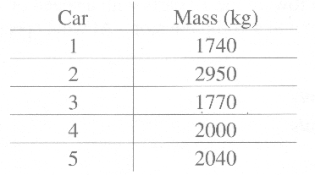

1. Each car was designed with energy‑absorbing crumple zones. Car 4, travelling at 100 km/h (27.8 m/s), was crashed into a wall and became 0.500 m shorter during impact. The average retarding force was

A. 1.36 × 106 N

B. 1.54 × 106 N

C. 1.57 × 106 N

D. 2.36 × 106 N

1. The automatic braking system in each car was designed to activate if the car encountered a sudden head‑on force equal to or greater than 1.25 × 104 N.The activator uses an instrument that measures average force. In which cars would the braking system activate if each vehicle were forced to stop from 100 km/h in 4.0 s?

A. 1, 2, and 4

B. 1, 3, and 4

C. 2, 3, and 5

D. 2, 4, and 5

1. The 1740 kg car travelling north on an icy test area was crashed into the 2000 kg car travelling west. The test designers found that the two vehicles locked together on impact and slid at 9.0 m/s at 35o west of north. What was the speed of the 1740 kg car just before impact?

A. 16 m/s

B. 11 m/s

C. 8.5 m/s

D. 5.9 m/s

*Use the following information to answer the next two questions.*

The initial speed of a remote-controlled toy car on a horizontal surface is 3.0 m/s. The car then experiences a force in the direction of its motion. A graph of this force as a function of time is given below. The mass of the car is 5.0 kg.



Two students analyze the motion of the car. One student looks at the first 1.0 s time interval. The other student looks at the complete 1.5 s time interval.

1. The speed of the toy car at the end of the 1.0 s time interval is

A. 1.4 m/s

B. 1.6 m/s

C. 4.6 m/s

D. 8.0 m/s

1. The magnitude of the impulse of the toy car during the 1.5 s time interval is

A. 10 kg⋅m/s

B. 12 kg⋅m/s

C. 24 kg⋅m/s

D. 40 kg⋅m/s

_____________________________________

1. Which of the following quantities is a **scalar** quantity?

A. Force

B. Power

C. Impulse

D. Momentum

Numerical Response

1. A golf club is in contact with the golf ball for 3.00 × 10-4 s, and the ball leaves the club with a speed of 72.0 m/s. The golf ball has a mass of 45.0 g. The average force exerted by the club on the ball, expressed in scientific notation, is ____× 10wN.

(Record your **three-digit answer** in the numerical-response section on the answer sheet.)

**Numerical Response**

*Use the following information to answer the next question.*

**Shadow Formation by a Point Source**

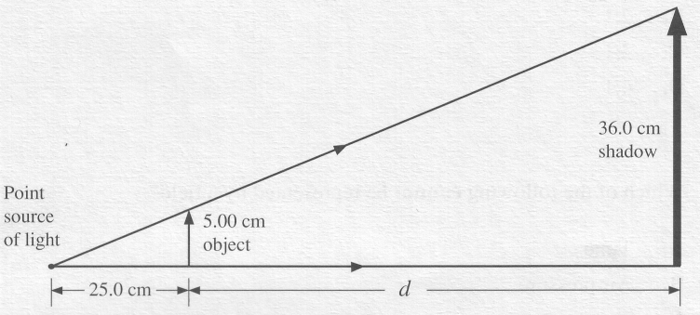

1. An object 5.00 cm high is placed 25.0 cm from a point source of light. A shadow 36.0 cm high appears on a screen. At what distance, *d*, behind the object is the screen placed?

A. 7.20 cm

B. 32.2 cm

C. 155 cm

D. 180 cm

__________________________________

1. If the fixed mirror in an eight sided Michelson’s mirror experiment is placed 65 km away from the rotating mirror, what is the frequency for the rotating mirror in order to give a successful experiment?

A. 144 Hz

B. 288 Hz

C. 576 Hz

D. 864 Hz

*Use the following information to answer the next question.*

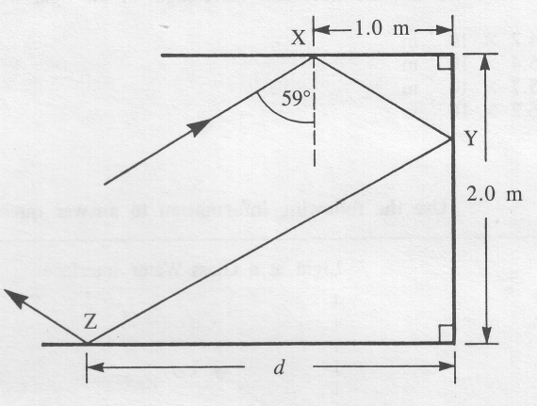

Light is incident upon a reflective surface at X and is further reflected at Y and Z.

1. The distance d is

A. 2.5 m

B. 2.3 m

C. 1.9 m

D. 1.7 m

______________________________

1. A 8.0 cm object is located 20 cm in front of a concave lens with a focal length of 10 cm. What is the size of the image produced by the lens?

A. + 2.67 cm

B. + 1.33 cm

C. – 4.00 cm

D. – 8.00 cm

1. A lens with a focal length of 4.0 cm generates an inverted image which is five times as large as the object. What is the object distance?

A. + 4.8 cm

B. + 9.6 cm

C. + 19.2 cm

D. + 24.0 cm

*Use the following information to answer the next question.*

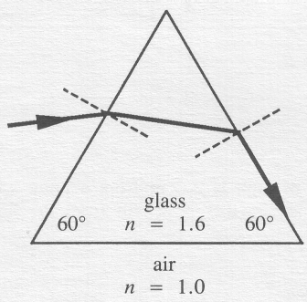

A ray of monochromatic light enters a glass prism and follows the path shown.

1. The angle of incidence at the first interface is

A. 13°

B. 21°

C. 36°

D. 39o

______________________________

*Use the following information to answer the next question.*

Liquid Resting on a Triangular Glass Prism

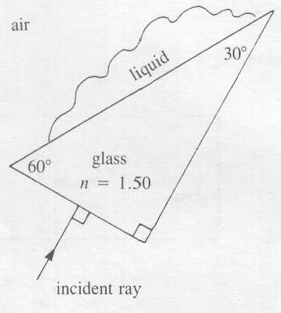

1. The maximum index of refraction of the liquid so that total internal reflection will occur is

A. 0.750

B. 1.30

C. 1.73

D. 3.00

____________________________________

*Use the following diagram to answer the next question.*

Blue light

Red light

1. Dispersion is the separation of light into its colors upon refraction through a prism. Blue light has a smaller angle of refraction than red light for the same angle of incidence. This indicates that

A. the index for blue light is smaller than the index for red light

B. the index for blue light is greater than the index for red light

C. the speed of blue light is faster than that of red light within the prism

D. the wavelength of blue light is greater than that of red light within the prism

*Use the following information to answer the next question.*

Light Striking a Glass Block

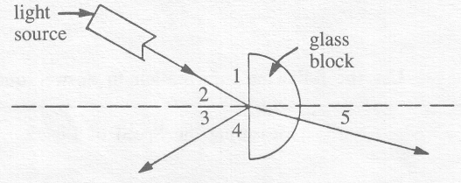

1. Which angles must be measured to show that the angle of incidence equals the angle of reflection?

A. 1 and 2

B. 1 and 5

C. 2 and 3

D. 2 and 5

_________________________________

*Use the following information to answer the next question.*

I. Light is a transverse wave.

II. Light is a longitudinal wave.

III. Light is always polarized.

IV. Polarized light vibrates in one plane.

V. Unpolarized light vibrates in random directions.

1. The wave nature of light is correctly described in statement(s)

A. II only

B. I and III

C. I, IV, and V

D. II, III, and IV

________________________________

1. Polarization of light can most easily be explained by assuming that light is a

A. transverse wave

B. longitudinal wave

C. stream of photons

D. stream of particles with different speeds

*Use the following information to answer the next question.*

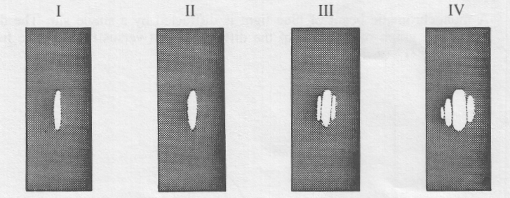

Each of the diagrams above represents a photograph produced when a beam of red light is directed through a narrow slit.

1. The slit with the narrowest opening was used to produce diagram

A. I

B. II

C. III

D. IV

__________________________________

1. Light illuminates two slits that are 0.10 cm apart and forms a diffraction pattern on a screen 12.0 m from the slits. If the first order image is formed 6.0 mm from the bright central band, what is the wavelength of the incident light?

A. 7.2 × 10-1 m

B. 2.0 × 10-2 m

C. 5.0 × 10-4 m

D. 5.0 × 10-7 m

1. Monochromatic light of wavelength 6.20 × 10-7 m falls on a diffraction grating at normal incidence. A screen is placed at a distance of 3.50 m from the grating. If the fourth-order bright band appears at an angle of 30.0° from the incident ray, the grating spacing is

A. 2.02 × 10-5 m

B. 4.96 × 10-6 m

C. 1.24 × 10-6 m

D. 8.27 × 10-8 m

1. The electric field strength that is just sufficient to suspend a proton in Earth's gravitational field near Earth's surface is

A. 8.94 × 10-30 N/C

B. 1.64 × 10-26 N/C

C. 5.58 × 10-11 N/C

D. 1.02 × 10-7 N/C

*Use the following information to answer the next question.*

**Electric Field from Two Point Charges**

Z

*P*

Y

W

X

q2

q1

**–**

**+**

In the diagram q1 and q2 are charges of equal magnitude but opposite sign. Point P is equidistant from q1 and q2.

1. The direction, of the net electric field at point P is the same as direction

A. W

B. X

C. Y

D. Z

______________________________

1. How much work is required to move a positive charge of 2.5 C between two points that have a potential difference of 60 V?

A. 0.15 mJ

B. 4.1 × 10‑8 J

C. 1.5 × 10‑7 J

D. 6.7 kJ

1. A negatively charged sphere X is brought near, but does not touch, a grounded sphere Y. The ground connection to sphere Y is removed, and then sphere X is moved away. If sphere Y is then touched to an identical but uncharged sphere Z, the nature of the charge on sphere Y and the nature of the charge on sphere Z, are, respectively,

A. negative and negative

B. positive and positive

C. positive and negative

D. negative and positive

1. Two equally charged particles repel each other with a force F. If their separation is doubled, they will repel each other with a force

A. 

B. 

C. 

D. 

*Use the following information to answer the next question.*

**Factors Related to Point Charges**

I the magnitude of the charge

II the sign of the charge

III the distance from the charge

IV the magnitude of the test charge

1. Which factors are needed to determine the magnitude and direction of the electric field  due to a point charge?

A. I and IV only

B. I, III, and IV only

C. I, II, and III only

D. I, II, III, and IV

______________________________

1. What is the distance between a stationary point charge of 1.20 × 10‑9 C and an alpha particle if the alpha particle initially accelerates at 7.35 × 108 m/s2?

A. 0.353 m

B. 0.594 m

C. 0.706 m

D. 0.840 m

1. The magnitude of the electrical force on an alpha particle that is 4.0 × 10-10 m from an electron is

A. 5.8 × 10-19 N

B. 1.2 × 10-18 N

C. 1.5 × 10-9 N

D. 2.9 × 10-9 N

1. In the absence of other forces, a charged particle entering an electric field will

A. change both its velocity and its kinetic energy

B. maintain both its velocity and its kinetic energy

C. maintain its velocity but change its kinetic energy

D. change its velocity but maintain its kinetic energy

1. The charges on two particles are 2.00 × 10-8 C and 4.00 × 10-8 C, respectively. The electrostatic force that the charges exert on each other is 1.00 × 10-3 N. The distance between the particles is

A. 1.39 × 102 m

B. 1.18 × 101 m

C. 8.48 × 10-2 m

D. 7.19 × 10-3 m

1. An oil drop with a mass of 5.74 × 10‑16 kg is suspended between two horizontal parallel plates. The magnitude of the electric field between the plates is 5.00 × 103 N/C. The magnitude of the charge on the drop is

A. 8.00 × 10-16 C

B. 1.13 × 10‑18 C

C. 1.60 × 10‑19 C

D. 1.15 × 10‑19 C

*Use the following information to answer the next three questions.*

To determine the electric force on a 2.5 × 10-4 kg neutral pith ball, a student charges a Van de Graff generator and suspends the pith ball by an insulating thread.

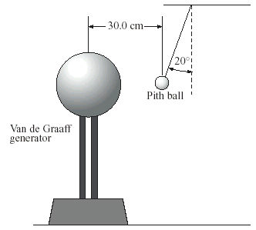

1. When the neutral pith ball is placed near the charged Van de Graff generator, the pith ball is attracted to the generator as a result of

A. induction

B. grounding

C. conduction

D. induction and grounding

1. The direction of the electrical force on the pith ball is

A. ←

B. →

C. ↑

D. ↓

1. The magnitude of the electrical force exerted on the pith ball by the charged Van de Graff generator is

A. 2.5 × 10-3 N

B. 2.3 × 10-3 N

C. 8.9 × 10-4 N

D. 8.4 × 10-4 N

______________________________

*Use the following diagram to answer the next question*.

Two positively charged spheres are placed at locations A and B, as shown below.

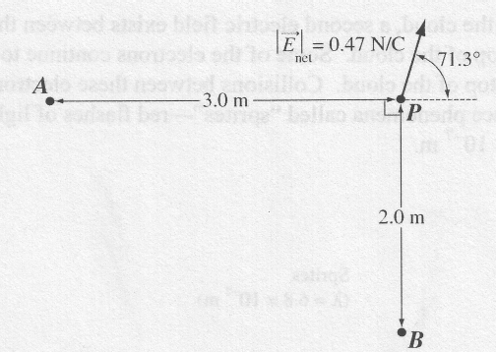

At point *P*, the net electric field is 0.47 N/C at 71.3° from the line between *A* and *P*. The net electric field is due to the charge at *A* and the charge at *B*.

1. The magnitude of the net electric field at point P that is caused by only the charge at B is

A. 1.4 N/C

B. 0.50 N/C

C. 0.45 N/C

D. 0.15 N/C

______________________________

Numerical Response

1. An electrical potential difference of 285 V is required to stop a moving alpha particle. The initial kinetic energy of the alpha particle, expressed in scientific notation, was ________ × 10-*w* J.

(Record your **three-digit answer** in the numerical-response section on the answer sheet.)

*Use the following information to answer the next question*.

Two small, electrically charged, metal spheres are fixed to insulating stands as shown below. The distance between the centres of the spheres is 0.500 m. Point *P* is 0.500 in from the centre of sphere B.

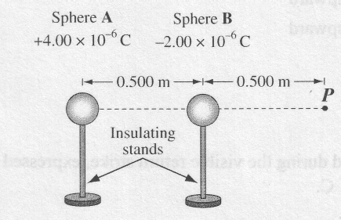

1. At point *P*, the magnitude of the net electric field caused by the charges on spheres A and B is

A. 2.16 × 105 N/C

B. 1.09 × 105 N/C

C. 7.19 × 104 N/C

D. 3.60 × 104 N/C

______________________________

1. An initially uncharged ebonite (hard rubber) rod is rubbed with an initially uncharged piece of cat's fur. As a result, the fur becomes positively charged and the ebonite becomes equally charged negative. This best illustrates

A. the law of conservation of charge

B. the law of conservation of mass

C. Coulomb's law

D. Faraday's law

*Use the following information to answer the next question.*

A popular game of young children is to shuffle across a carpet with stocking feet and then touch a friend. The spark that can be generated is caused by a charge buildup from the friction of the socks on the carpet.

1. Two friends, Sam and Jeff, shuffled on a carpet and obtained approximately the same negative charge. They then stood shoulder to shoulder without touching. A third friend, Cale, who was not charged, touched Jeff on the shoulder farthest from Sam. What is the nature of the final charges on the three boys?

A. Sam, Jeff, and Cale are all negatively charged.

B. Jeff and Cale are uncharged, and Sam is negatively charged.

C. Sam and Cale are negatively charged, and Jeff is positively charged.

D. Sam is negatively charged, and Jeff and Cale are positively charged.

______________________________

1. Three pithballs hang in an isolated container. Ball X has a charge of 1.0 × 10‑9 C, and balls Y and Z are neutral. Ball X is brought momentarily into contact with ball Y, then separated. Ball Y is then brought momentarily into contact with ball Z, then separated. When placed 1.0 m apart, balls X and Z will now exert a force on each other of magnitude

A. 1.0 × 10‑9 N

B. 1.1 × 10‑9 N

C. 2.2 × 10‑9 N

D. 9.0 × 10‑9 N

*Use the following information to answer the next question*.

A group of students wanted to determine which of four different objects would experience an electrostatic force of repulsion from the negatively charged top of a Van de Graaff generator.

Objects Selected by the Students

I Neutral polystyrene ball

II Positively charged polystyrene ball

III Negatively charged polystyrene ball

IV North end of a bar magnet

1. Which of the objects selected by the students will experience a force of repulsion from the top of the generator?

A. Object III only

B. Objects I and III only

C. Objects II and IV only

D. Objects III and IV only

______________________________

*Use the following information to answer the next question*.

Two charged spheres are positioned on a horizontal, frictionless insulating surface, as shown below.

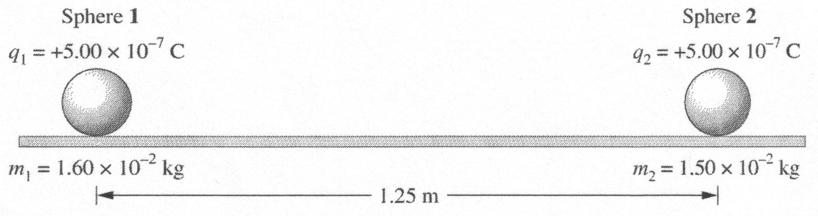

1. In the arrangement above, the magnitude of the instantaneous acceleration of sphere 2 will be

A. 1.20 × 10‑1 m/s2

B. 1.12 × 10‑1 m/s2

C. 9.59 × 10‑2 m/s2

D. 8.99 × 10‑2 m/s2

_______________________________

*Use the following information to answer the next question.*

Two small metal spheres are fixed to insulated stands and given static charges of –4.00 × 10-6 C and +2.00 × 10–6 C, respectively. The spheres are then placed 0.500 m apart. Point *P* is halfway between the charged spheres.

1. At point *P*, the magnitude of the electric field caused by the two charged spheres is

A. 8.63 × 105 N/C

B. 2.88 × 105 N/C

C. 2.16 × 105 N/C

D. 7.19 × 104 N/C

*Use the following information to answer the next question.*

In all electronic camera flashes, there is a capacitor, which is a device that allows large quantities of charge to be stored. The charge accumulates and is then released very quickly.

The electrical energy stored in a capacitor is given by ,

where V= potential difference across the capacitor

and C= the capacitance of the capacitor in farads

1. Which of the following combinations of coulombs, joules, and/or volts is equivalent to a farad?

A. 

B. 

C. 

D. 

**Answers**

**Multiple choice Numerical Response**

|  |  |  |  |
| --- | --- | --- | --- |
| 1. B 2. D 3. A 4. C 5. A 6. B 7. C 8. B 9. B 10. A 11. A 12. C 13. B 14. B 15. C | 1. C 2. A 3. D 4. D 5. B 6. D 7. A 8. A 9. B 10. A 11. C 12. D 13. D 14. A 15. C | 1. B 2. A 3. A 4. C 5. C 6. D 7. A 8. A 9. B 10. A 11. C 12. C 13. A | 1. 1.08 2. 9.12 |